# Exploring Weather Trends - Project 1

In this project, I tried to understand the correlations between global temperatures and local temperatures.

I am from Mumbai, India. So, I chose a city near me - Pune as the local to plot the chart from.

## Steps

1. Extracting the Data from the database

I used the SQL Queries to generate 2 CSV files, one with the local temperature data and one with the global temperature data.

I used simple select statements to achieve this. A better way would have been using inner or left joins but the Udacity SQL Workbench kept crashing when I tried to do that.

SQL Commands Used -

**SELECT year, avg_temp FROM city_data where city='Pune';**

**SELECT * FROM global_data where year>=1796 and year<=2013;**

1. Calculating Moving Averages

I used Google Sheets to open the 2 CSV and then pasted them into one.

I used the filter option to drop the rows which were empty for the local data.

I had initially forgotten to calculate the moving averages and that made my line chart look wonky, but I fixed it as soon as I remembered to.

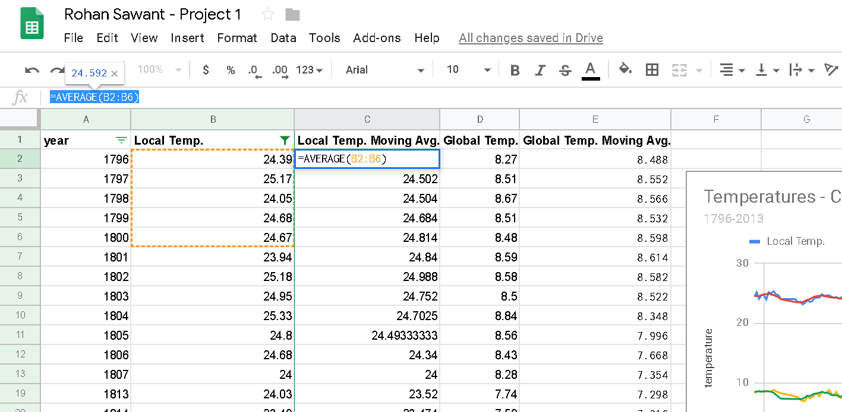

I decided to take 5-year moving averages. I calculated the moving averages using the following formula.

**=AVERAGE(B2:B6)**

I repeated the same procedure for calculating the moving averages of the Global temperatures.

1. Drawing the Line Chart

I then proceeded to use the Line Charts Tool to draw the line charts.

I have plotted both the Local Temp and the Global Temperature with their respective moving averages.

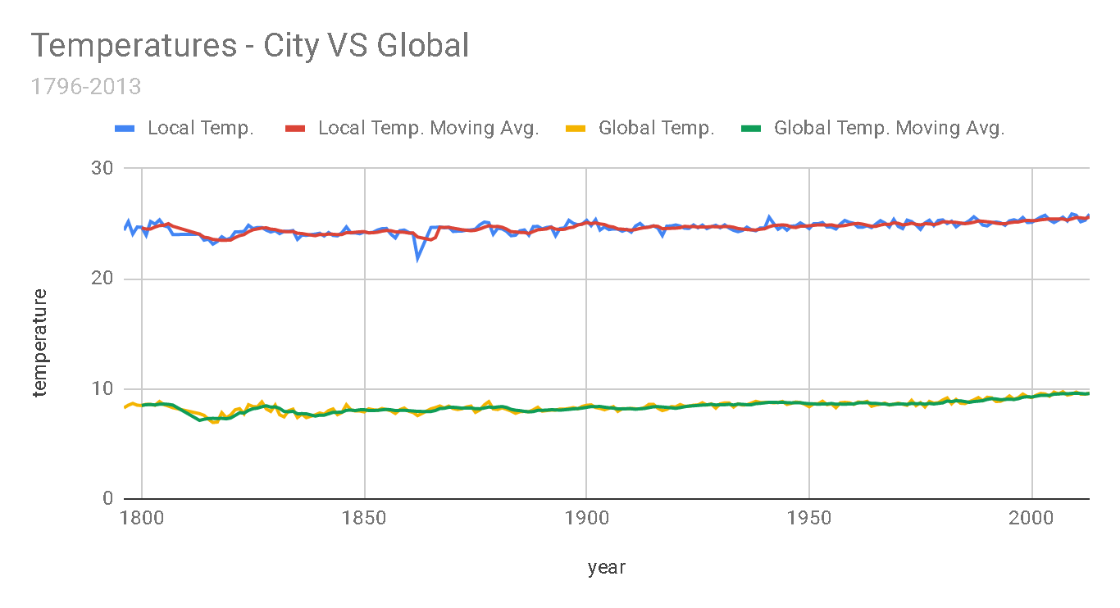

1. Making Observations

I then moved on to making some simple observations about the data.

## Observations

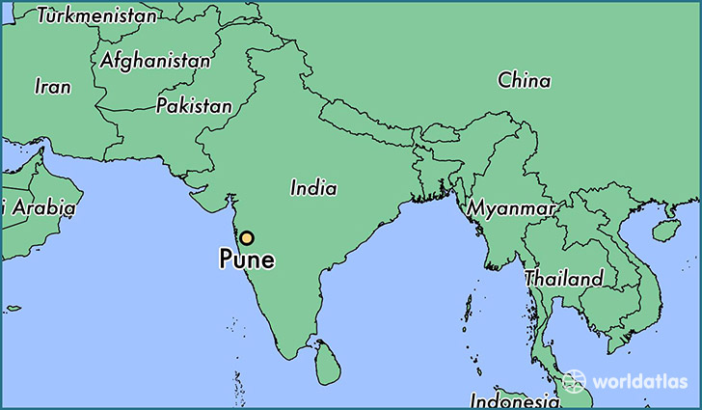

### Pune is hotter than the average global temperature

Pune is close to the equator and lies on the western shore of India, this could be one of the reasons it is hotter than the average global temperature.

### Pune V/ Average Global Temperatures

It is easily apparent that Pune closely follows the general trend of the average global temperatures.

### Jump in average global temperatures after the industrial revolution during the 19th century

We can see a slight increase in the average global temperature after the Industrial Revolution, due to the increase in the burning of fossil fuels and the eventual global warming.

### Pune is following the Global Temperature Trend.

The Global Average temperate is rising and that is apparent from the Chart, with it we also see that the Local temperature in Pune is also rising. This means that Pune is following the Global temperature trend.

### The World is getting hotter

There is a visible upward trend in the average global temperatures since the last few hundred years.

## Appendix

This is the table which was created as I worked on the project.

|  |  |  |  |  |
| --- | --- | --- | --- | --- |
| **year** | **Local Temp.** | **Local Temp. Moving Avg.** | **Global Temp.** | **Global Temp. Moving Avg.** |
| 1796 | 24.39 |  | 8.27 |  |
| 1797 | 25.17 |  | 8.51 |  |
| 1798 | 24.05 |  | 8.67 |  |
| 1799 | 24.68 |  | 8.51 |  |
| 1800 | 24.67 | 24.592 | 8.48 | 8.488 |
| 1801 | 23.94 | 24.502 | 8.59 | 8.552 |
| 1802 | 25.18 | 24.504 | 8.58 | 8.566 |
| 1803 | 24.95 | 24.684 | 8.5 | 8.532 |
| 1804 | 25.33 | 24.814 | 8.84 | 8.598 |
| 1805 | 24.8 | 24.84 | 8.56 | 8.614 |
| 1806 | 24.68 | 24.988 | 8.43 | 8.582 |
| 1807 | 24 | 24.752 | 8.28 | 8.522 |
| 1813 | 24.03 | 24.03 | 7.74 | 7.13 |
| 1814 | 23.49 | 23.76 | 7.59 | 7.232 |
| 1815 | 23.58 | 23.7 | 7.24 | 7.296 |
| 1816 | 23.13 | 23.5575 | 6.94 | 7.312 |
| 1817 | 23.37 | 23.52 | 6.98 | 7.298 |
| 1818 | 23.8 | 23.474 | 7.83 | 7.316 |
| 1819 | 23.54 | 23.484 | 7.37 | 7.272 |
| 1820 | 23.67 | 23.502 | 7.62 | 7.348 |
| 1821 | 24.24 | 23.724 | 8.09 | 7.578 |
| 1822 | 24.25 | 23.9 | 8.19 | 7.82 |
| 1823 | 24.28 | 23.996 | 7.72 | 7.798 |
| 1824 | 24.84 | 24.256 | 8.55 | 8.034 |
| 1825 | 24.54 | 24.43 | 8.39 | 8.188 |
| 1826 | 24.64 | 24.51 | 8.36 | 8.242 |
| 1827 | 24.64 | 24.588 | 8.81 | 8.366 |
| 1828 | 24.4 | 24.612 | 8.17 | 8.456 |
| 1829 | 24.23 | 24.49 | 7.94 | 8.334 |
| 1830 | 24.36 | 24.454 | 8.52 | 8.36 |
| 1831 | 24.08 | 24.342 | 7.64 | 8.216 |
| 1832 | 24.29 | 24.272 | 7.45 | 7.944 |
| 1833 | 24.29 | 24.25 | 8.01 | 7.912 |
| 1834 | 24.36 | 24.276 | 8.15 | 7.954 |
| 1835 | 23.56 | 24.116 | 7.39 | 7.728 |
| 1836 | 23.96 | 24.092 | 7.7 | 7.74 |
| 1837 | 23.92 | 24.018 | 7.38 | 7.726 |
| 1838 | 23.99 | 23.958 | 7.51 | 7.626 |
| 1839 | 24.04 | 23.894 | 7.63 | 7.522 |
| 1840 | 24.12 | 24.006 | 7.8 | 7.604 |
| 1841 | 23.87 | 23.988 | 7.69 | 7.602 |
| 1842 | 24.18 | 24.04 | 8.02 | 7.73 |
| 1843 | 23.92 | 24.026 | 8.17 | 7.862 |
| 1844 | 23.88 | 23.994 | 7.65 | 7.866 |
| 1845 | 24.17 | 24.004 | 7.85 | 7.876 |
| 1846 | 24.69 | 24.168 | 8.55 | 8.048 |
| 1847 | 24.15 | 24.162 | 8.09 | 8.062 |
| 1848 | 24.15 | 24.208 | 7.98 | 8.024 |
| 1849 | 24.07 | 24.246 | 7.98 | 8.09 |
| 1850 | 24.23 | 24.258 | 7.9 | 8.1 |
| 1851 | 24.16 | 24.152 | 8.18 | 8.026 |
| 1852 | 24.2 | 24.162 | 8.1 | 8.028 |
| 1853 | 24.41 | 24.214 | 8.04 | 8.04 |
| 1854 | 24.53 | 24.306 | 8.21 | 8.086 |
| 1855 | 24.55 | 24.37 | 8.11 | 8.128 |
| 1856 | 24.04 | 24.346 | 8 | 8.092 |
| 1857 | 23.69 | 24.244 | 7.76 | 8.024 |
| 1858 | 24.35 | 24.232 | 8.1 | 8.036 |
| 1859 | 24.41 | 24.208 | 8.25 | 8.044 |
| 1860 | 24.19 | 24.136 | 7.96 | 8.014 |
| 1861 | 24.06 | 24.14 | 7.85 | 7.984 |
| 1862 | 21.86 | 23.774 | 7.56 | 7.944 |
| 1865 | 24.64 | 23.52 | 8.18 | 7.936 |
| 1866 | 24.65 | 23.71666667 | 8.29 | 8.024 |
| 1867 | 24.69 | 24.66 | 8.44 | 8.2 |
| 1868 | 24.61 | 24.6475 | 8.25 | 8.228 |
| 1869 | 24.66 | 24.65 | 8.43 | 8.318 |
| 1870 | 24.28 | 24.578 | 8.2 | 8.322 |
| 1871 | 24.31 | 24.51 | 8.12 | 8.288 |
| 1872 | 24.32 | 24.436 | 8.19 | 8.238 |
| 1873 | 24.4 | 24.394 | 8.35 | 8.258 |
| 1874 | 24.42 | 24.346 | 8.43 | 8.258 |
| 1875 | 24.49 | 24.388 | 7.86 | 8.19 |
| 1876 | 24.89 | 24.504 | 8.08 | 8.182 |
| 1877 | 25.13 | 24.666 | 8.54 | 8.252 |
| 1878 | 25.07 | 24.8 | 8.83 | 8.348 |
| 1879 | 24.03 | 24.722 | 8.17 | 8.296 |
| 1880 | 24.57 | 24.738 | 8.12 | 8.348 |
| 1881 | 24.51 | 24.662 | 8.27 | 8.386 |
| 1882 | 24.29 | 24.494 | 8.13 | 8.304 |
| 1883 | 23.89 | 24.258 | 7.98 | 8.134 |
| 1884 | 23.94 | 24.24 | 7.77 | 8.054 |
| 1885 | 24.34 | 24.194 | 7.92 | 8.014 |
| 1886 | 24.42 | 24.176 | 7.95 | 7.95 |
| 1887 | 23.94 | 24.106 | 7.91 | 7.906 |
| 1888 | 24.72 | 24.272 | 8.09 | 7.928 |
| 1889 | 24.74 | 24.432 | 8.32 | 8.038 |
| 1890 | 24.51 | 24.466 | 7.97 | 8.048 |
| 1891 | 24.64 | 24.51 | 8.02 | 8.062 |
| 1892 | 24.7 | 24.662 | 8.07 | 8.094 |
| 1893 | 23.89 | 24.496 | 8.06 | 8.088 |
| 1894 | 24.55 | 24.458 | 8.16 | 8.056 |
| 1895 | 24.6 | 24.476 | 8.15 | 8.092 |
| 1896 | 25.29 | 24.606 | 8.21 | 8.13 |
| 1897 | 25.01 | 24.668 | 8.29 | 8.174 |
| 1898 | 24.89 | 24.868 | 8.18 | 8.198 |
| 1899 | 24.95 | 24.948 | 8.4 | 8.246 |
| 1900 | 25.29 | 25.086 | 8.5 | 8.316 |
| 1901 | 24.81 | 24.99 | 8.54 | 8.382 |
| 1902 | 25.35 | 25.058 | 8.3 | 8.384 |
| 1903 | 24.41 | 24.962 | 8.22 | 8.392 |
| 1904 | 24.69 | 24.91 | 8.09 | 8.33 |
| 1905 | 24.45 | 24.742 | 8.23 | 8.276 |
| 1906 | 24.51 | 24.682 | 8.38 | 8.244 |
| 1907 | 24.49 | 24.51 | 7.95 | 8.174 |
| 1908 | 24.3 | 24.488 | 8.19 | 8.168 |
| 1909 | 24.47 | 24.444 | 8.18 | 8.186 |
| 1910 | 24.22 | 24.398 | 8.22 | 8.184 |
| 1911 | 24.78 | 24.452 | 8.18 | 8.144 |
| 1912 | 25.01 | 24.556 | 8.17 | 8.188 |
| 1913 | 24.64 | 24.624 | 8.3 | 8.21 |
| 1914 | 24.69 | 24.668 | 8.59 | 8.292 |
| 1915 | 24.79 | 24.782 | 8.59 | 8.366 |
| 1916 | 24.59 | 24.744 | 8.23 | 8.376 |
| 1917 | 23.91 | 24.524 | 8.02 | 8.346 |
| 1918 | 24.76 | 24.548 | 8.13 | 8.312 |
| 1919 | 24.78 | 24.566 | 8.38 | 8.27 |
| 1920 | 24.87 | 24.582 | 8.36 | 8.224 |
| 1921 | 24.77 | 24.618 | 8.57 | 8.292 |
| 1922 | 24.57 | 24.75 | 8.41 | 8.37 |
| 1923 | 24.56 | 24.71 | 8.42 | 8.428 |
| 1924 | 24.87 | 24.728 | 8.51 | 8.454 |
| 1925 | 24.61 | 24.676 | 8.53 | 8.488 |
| 1926 | 24.86 | 24.694 | 8.73 | 8.52 |
| 1927 | 24.54 | 24.688 | 8.52 | 8.542 |
| 1928 | 24.71 | 24.718 | 8.63 | 8.584 |
| 1929 | 24.84 | 24.712 | 8.24 | 8.53 |
| 1930 | 24.61 | 24.712 | 8.63 | 8.55 |
| 1931 | 24.88 | 24.716 | 8.72 | 8.548 |
| 1932 | 24.59 | 24.726 | 8.71 | 8.586 |
| 1933 | 24.38 | 24.66 | 8.34 | 8.528 |
| 1934 | 24.26 | 24.544 | 8.63 | 8.606 |
| 1935 | 24.37 | 24.496 | 8.52 | 8.584 |
| 1936 | 24.67 | 24.454 | 8.55 | 8.55 |
| 1937 | 24.43 | 24.422 | 8.7 | 8.548 |
| 1938 | 24.34 | 24.414 | 8.86 | 8.652 |
| 1939 | 24.6 | 24.482 | 8.76 | 8.678 |
| 1940 | 24.59 | 24.526 | 8.76 | 8.726 |
| 1941 | 25.57 | 24.706 | 8.77 | 8.77 |
| 1942 | 25 | 24.82 | 8.73 | 8.776 |
| 1943 | 24.48 | 24.848 | 8.76 | 8.756 |
| 1944 | 24.75 | 24.878 | 8.85 | 8.774 |
| 1945 | 24.4 | 24.84 | 8.58 | 8.738 |
| 1946 | 24.76 | 24.678 | 8.68 | 8.72 |
| 1947 | 24.79 | 24.636 | 8.8 | 8.734 |
| 1948 | 25.06 | 24.752 | 8.75 | 8.732 |
| 1949 | 24.82 | 24.766 | 8.59 | 8.68 |
| 1950 | 24.54 | 24.794 | 8.37 | 8.638 |
| 1951 | 24.98 | 24.838 | 8.63 | 8.628 |
| 1952 | 24.98 | 24.876 | 8.64 | 8.596 |
| 1953 | 25.09 | 24.882 | 8.87 | 8.62 |
| 1954 | 24.68 | 24.854 | 8.56 | 8.614 |
| 1955 | 24.68 | 24.882 | 8.63 | 8.666 |
| 1956 | 24.5 | 24.786 | 8.28 | 8.596 |
| 1957 | 24.95 | 24.78 | 8.73 | 8.614 |
| 1958 | 25.28 | 24.818 | 8.77 | 8.594 |
| 1959 | 25.11 | 24.904 | 8.73 | 8.628 |
| 1960 | 25.02 | 24.972 | 8.58 | 8.618 |
| 1961 | 24.66 | 25.004 | 8.8 | 8.722 |
| 1962 | 24.66 | 24.946 | 8.75 | 8.726 |
| 1963 | 24.8 | 24.85 | 8.86 | 8.744 |
| 1964 | 24.63 | 24.754 | 8.41 | 8.68 |
| 1965 | 24.96 | 24.742 | 8.53 | 8.67 |
| 1966 | 25.26 | 24.862 | 8.6 | 8.63 |
| 1967 | 25.05 | 24.94 | 8.7 | 8.62 |
| 1968 | 24.68 | 24.916 | 8.52 | 8.552 |
| 1969 | 25.37 | 25.064 | 8.6 | 8.59 |
| 1970 | 24.74 | 25.02 | 8.7 | 8.624 |
| 1971 | 24.54 | 24.876 | 8.6 | 8.624 |
| 1972 | 25.31 | 24.928 | 8.5 | 8.584 |
| 1973 | 25.18 | 25.028 | 8.95 | 8.67 |
| 1974 | 24.87 | 24.928 | 8.47 | 8.644 |
| 1975 | 24.47 | 24.874 | 8.74 | 8.652 |
| 1976 | 25.05 | 24.976 | 8.35 | 8.602 |
| 1977 | 25.3 | 24.974 | 8.85 | 8.672 |
| 1978 | 24.81 | 24.9 | 8.69 | 8.62 |
| 1979 | 25.28 | 24.982 | 8.73 | 8.672 |
| 1980 | 25.33 | 25.154 | 8.98 | 8.72 |
| 1981 | 25 | 25.144 | 9.17 | 8.884 |
| 1982 | 25.21 | 25.126 | 8.64 | 8.842 |
| 1983 | 24.7 | 25.104 | 9.03 | 8.91 |
| 1984 | 24.99 | 25.046 | 8.69 | 8.902 |
| 1985 | 25.02 | 24.984 | 8.66 | 8.838 |
| 1986 | 25.26 | 25.036 | 8.83 | 8.77 |
| 1987 | 25.61 | 25.116 | 8.99 | 8.84 |
| 1988 | 25.29 | 25.234 | 9.2 | 8.874 |
| 1989 | 24.86 | 25.208 | 8.92 | 8.92 |
| 1990 | 24.78 | 25.16 | 9.23 | 9.034 |
| 1991 | 25.06 | 25.12 | 9.18 | 9.104 |
| 1992 | 25.14 | 25.026 | 8.84 | 9.074 |
| 1993 | 25.06 | 24.98 | 8.87 | 9.008 |
| 1994 | 24.84 | 24.976 | 9.04 | 9.032 |
| 1995 | 25.24 | 25.068 | 9.35 | 9.056 |
| 1996 | 25.34 | 25.124 | 9.04 | 9.028 |
| 1997 | 25.21 | 25.138 | 9.2 | 9.1 |
| 1998 | 25.55 | 25.236 | 9.52 | 9.23 |
| 1999 | 25.1 | 25.288 | 9.29 | 9.28 |
| 2000 | 25.11 | 25.262 | 9.2 | 9.25 |
| 2001 | 25.34 | 25.262 | 9.41 | 9.324 |
| 2002 | 25.58 | 25.336 | 9.57 | 9.398 |
| 2003 | 25.75 | 25.376 | 9.53 | 9.4 |
| 2004 | 25.32 | 25.42 | 9.32 | 9.406 |
| 2005 | 25.09 | 25.416 | 9.7 | 9.506 |
| 2006 | 25.31 | 25.41 | 9.53 | 9.53 |
| 2007 | 25.58 | 25.41 | 9.73 | 9.562 |
| 2008 | 25.23 | 25.306 | 9.43 | 9.542 |
| 2009 | 25.87 | 25.416 | 9.51 | 9.58 |
| 2010 | 25.75 | 25.548 | 9.7 | 9.58 |
| 2011 | 25.16 | 25.518 | 9.52 | 9.578 |
| 2012 | 25.3 | 25.462 | 9.51 | 9.534 |
| 2013 | 25.85 | 25.586 | 9.61 | 9.57 |